Automata Theory

Jonny Hughes

1/28/20

Homework 3

1. all strings with 1's only in even-length subsequences
   1. 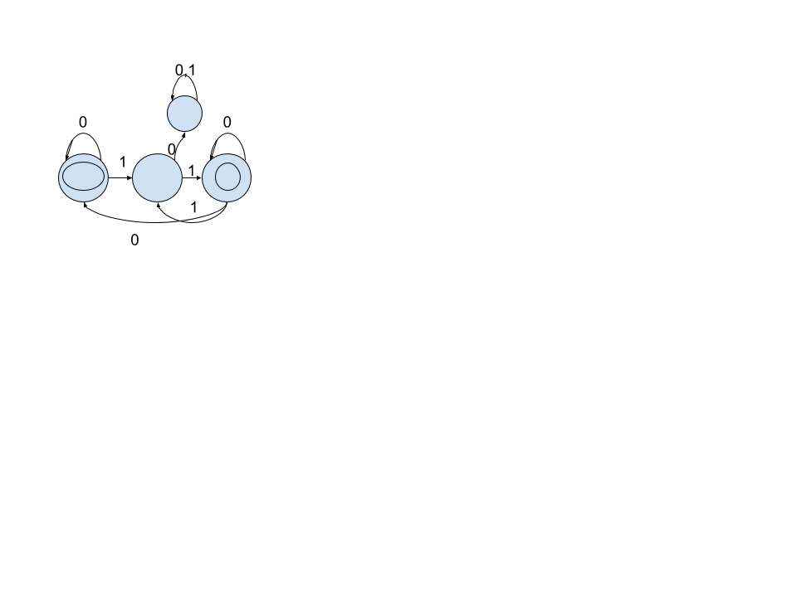
2. all strings with both 01 and 10 as substrings
   1. 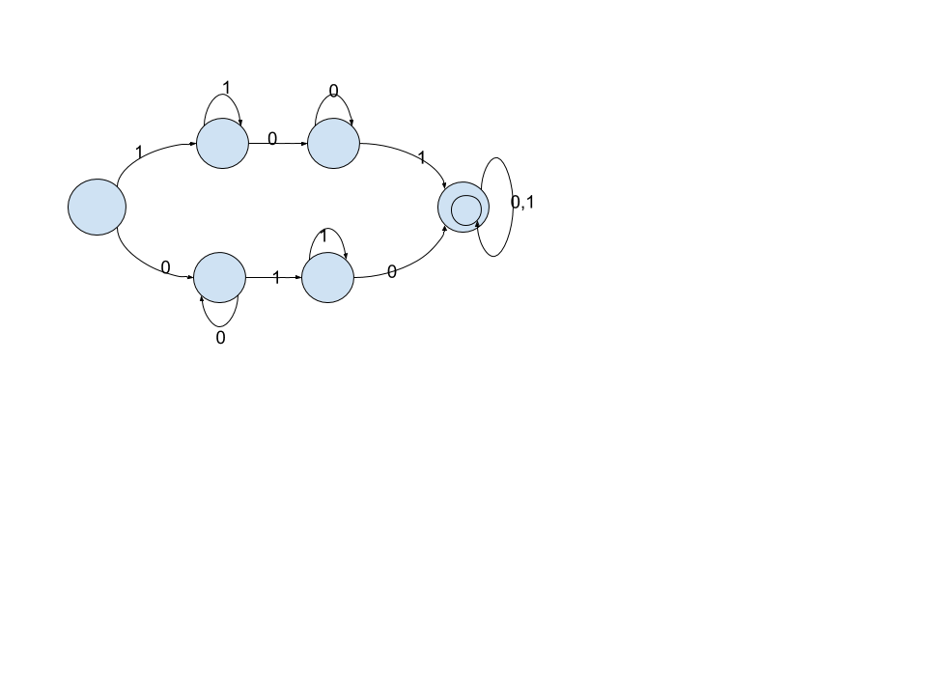
3. all strings that contain at least one double symbol ( **00** or **11** ) as a substring
   1. 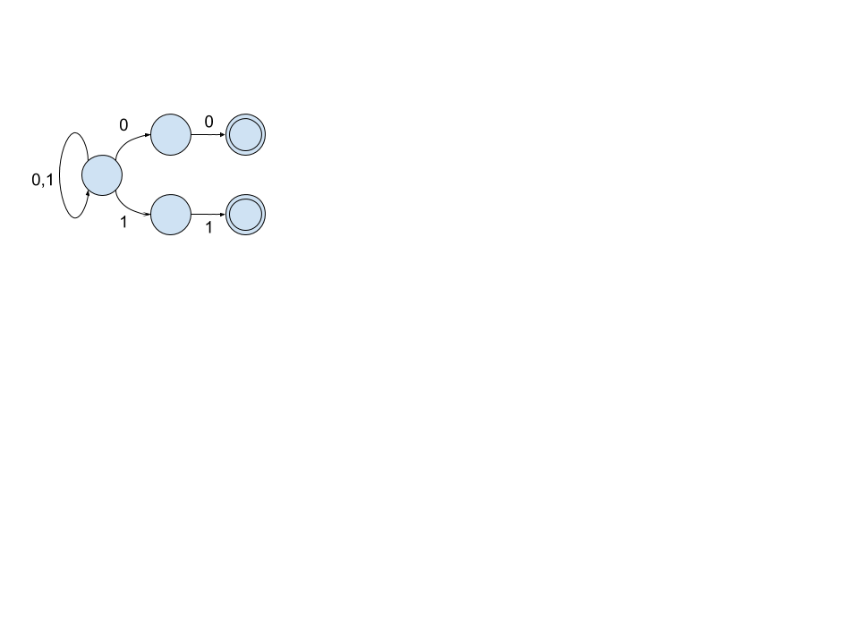
4. all strings that contain do not contain any double symbol ( **00** or **11** ) as a substring
   1. 